Efficiency Analysis of Ripple Mill Capacity 6 Ton/Hours on Maintenance Machine
Ahdiat Leksi Siregar^{1*}, Riyansa Devi Zulfiah², Istianto Budhi Rahardja³, Azhar Basyir Rantawi⁴, Hendra Saputera⁵
^{1,2,3,4,5}Politeknik Kelapa Sawit Citra Widya Edukasi, Gapura 8 street, Rawa Banteng, Setu, Cibitung, Bekasi, 17520, Indonesia

A R T I C L E I N F O a B S T R A C T

JASAT use only:  Received date :  Revised date :  Accepted date :  Keywords:  Ripple Mill ,  Nut & Kernel ,  Machine Performance Efficiency,  Ripple Mill Working Hours |  | Ripple mill is a machine used to crush palm kernels at the nut & kernel station. This research aims to find out how the ripple mill machine works and determine the relationship between machine maintenance carried out on the performance efficiency of the ripple mill. The working principle of a ripple mill is that palm kernels that are fed into the ripple mill will be ground and crushed between the rotor and stator with an engine speed of 1200 rpm. The components contained in the ripple mill are the rotor bar which consists of 40 bars arranged in a circle, the stator bar consists of 18 bars at the front and 18 bars at the back, the v-belt pulley used is of the type B65 and B67 according to the position of the motor, then the flange bearing is used as a position for the shaft on the rotor before connecting to the pulley. Based on the results of research that has been carried out, it was found that the feed entering the ripple mill is 5.6 tons / hour with an installed capacity of 6 tons / hour. The working hours that have been set for the ripple mill are 300 operating hours, after observations it was obtained that it was 320 operating hours with the efficiency results obtained remaining in accordance with the predetermined standards, namely 95% - 99%.  © 2023 Journal of Applied Science and Advanced Technology. All rights reserved

Introduction∗

A palm oil factory is a factory that processes FFB (Fresh Fruit Bunches) raw materials into CPO (Crude Palm Oil) and PK (Palm Kernel) by minimizing losses, optimal efficiency, quality according to standards, minimal costs by referring to SOP (Standards Operational Procedure) [1-4]. To produce CPO and PK there are several processes such as boiling the FFB, shelling, chopping, and others [5-7]. The processing process at the palm oil factory is as follows:
- Fruit reception station
- Boiling station (Sterilizer station)
- Threshing station
- Chopping and pressing station (Digester & press station)
- Purification Station (Clarifier station)
- Seed and kernel separation station (Nut & kernel station)
The CPO product produced is the result of processing at the clarifier station, while PK is the result of processing at the nut & kernel station [9-10].
Ripple mill is a machine at the nut & kernel station which is used to break palm kernels (nuts) by pressing the palm kernels using a rotor with a stator, resulting in the palm kernels being split. This solution is done so that the shell and kernel are separated [11-13]. Solving will be said to be efficient if the ripple mill efficiency results are 95% - 99%. To determine the efficiency of the ripple mill in accordance with standards, tests will be carried out on the output of the ripple mill, namely cracked mixture [14-17].

Methods

2.1 Maintenance
Maintenance is an activity in industry that is used to maintain and maintain or maintain the quality of a machine so that the machine can work efficiently and optimally, thereby reducing the level of machine damage which can cause the processing process to stop [18-19].
Maintenance activities carried out on company machines and tools require appropriate methods and procedures. Therefore, maintenance management needs to plan inspection schedules or replacement of machine components to ensure that the company's operational activities run smoothly and avoid breakdowns. The types of maintenance activities are preventive maintenance and repair maintenance.
  - Preventive maintenance
Preventive maintenance is a maintenance activity that aims to prevent unexpected damage during processing which could result in production being hampered resulting in losses [20].
The aim of carrying out preventive maintenance is to reduce:
- Equipment damage.
- Component wear.
- Sudden cessation of processing.
  - Repair maintenance
Repair maintenance, also known as corrective maintenance, is maintenance or maintenance activities carried out when the machine experiences damage so that the machine cannot function properly. This activity is often referred to as reparation (improvement activity). This corrective maintenance activity is only carried out when the machine can really no longer be used or the performance results of the machine are no longer suitable, then repairs must be carried out [21].
2.4 Ripple Mill Machine
Ripple mill is a machine at the nut & kernel station which functions as a tool for breaking palm kernels, namely separating the palm oil shell from the palm kernel or kernel. The way the ripple mill itself works is that the palm seeds (nuts) that are fed into the ripple mill will be ground and crushed between the stationary stator bar and the moving rotor bar. The working results of this ripple mill depend on the size of the palm kernels being fed, filling too much palm kernel will cause the rotor and stator to experience wear and tear and the operating hours of the ripple mill will exceed its useful life. These things will influence whether the ripple mill machine is effective or ineffective.

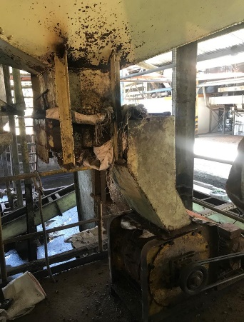
Figure 1. Ripple mill

  - Cracked mixture
The material that goes as feed into the ripple mill is palm kernel (nut), where the palm kernel will be stored first in the nut hopper before entering the ripple mill.
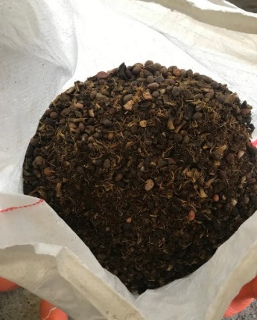
Figure 2. Cracked Mixture
  - Ripple mill efficiency
This efficiency is a measure of success which is assessed in terms of how large or small the results of a machine's work are.
According to Siregar (2018), cracked mixture consists of several materials, such as heavy material, namely kernels and round nuts, medium material, namely broken kernels and broken nuts, and light material, namely shell. To calculate the efficiency of a ripple mill, you can use the following equation:

% Round Nut = (W2/W1) x 100 ............... (2.1)
% Broken Nut = (W3/W1) x 100 .............. (2.2)
% Round Kernel = (W4/W1) x 100 ........... (2.3)
% Broken AKernel = (W5/W1) x 100 .......... (2.4)
Effesience = 100 - % Round Nut - % Broken Nut .......(2.5)

Information:
W1 = Sample weight (grams)
W2 = Weight of round nut (grams)
W3 = Weight of broken nut (grams)
W4 = Round kernel weight (grams)
W5 = Weight of broken kernels (grams)

2.7 Framework of Thinking

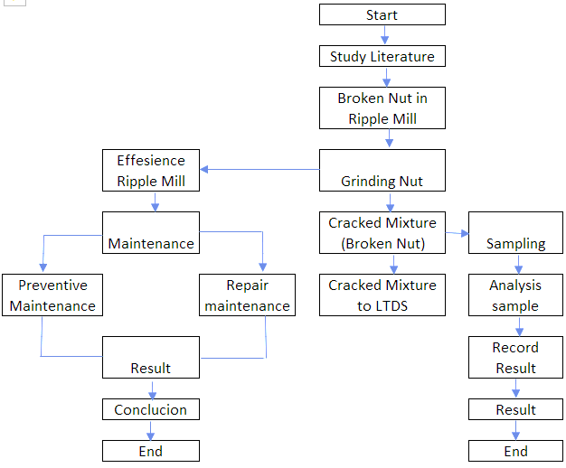
Figure 3. Schematic Research

Results and Discussions

At the palm oil processing factory at PT Unggul Widya Teknologi Lestari there are 4 ripple mills , only 2 are operational while the other 2 are on standby, where the specifications for each ripple mill are the same, namely regarding capacity, model, machine length, machine width, machine height and motor speed. The results of the transmission of motorbike rotation to engine speed are 1500 rpm: 1200 rpm.
The working principle or workings of a ripple mill is always supported by the health of each component. Things that influence the efficiency of a ripple mill include the size of the palm kernels fed, the spacing between the rotor bar and the stator bar, wear and tear on the rotor and stator, the amount of feed fed, and fiber that is still included in the palm kernels. The feed that enters the ripple mill machine after averaging is 5.6 tons/hour.
The maintenance that is usually carried out during maintenance and repairs at the PT UWTL ripple mill is preventive maintenance and repair maintenance. Preventive maintenance is maintenance that is carried out routinely every day. During the repair maintenance, adjustments and replacements were carried out on the rotor bar, during the author's research on ripple mill number 4, there were 3 adjustments and 1 replacement, starting from 02 July 2021 - 5 August 2021. In each maintenance carried out, the reference was seen from the results of the work. Ripple mill or what is usually called ripple mill efficiency, if the efficiency of the ripple mill decreases then adjustment will be carried out first and if wear occurs then the worn ripple mill components will be replaced. The efficiency of the ripple mill at PT UWTL is expected to be 95%-99%. It is known that the working hours on the ripple mill exceed the standard working hours that have been set, namely reaching 320 hours/unit, but in this case the efficiency of the ripple mill still reaches 95% - 99%.
Efficiency testing on the ripple mill was carried out at the PT UWTL. Where the steps in the test are to separate round nuts, broken nuts, round kernels and broken kernels, then calculate the efficiency of the ripple mill.
  - Ripple mill specifications
In the palm oil processing factory, there are 4 ripples with the same specifications. The specifications are as follows:

Table 1. Spesification Ripple Mill
Machine | Ripple Mill
Capacity | 6 Ton/Jam
Model | 16-18V PEL-TEC
Long Machine | 44 cm
Wide Machine | 68 cm
Height Machine | 56 cm
Round Motor | 1500 Rpm
Round Mesin | 1200 Rpm
Amount | 4

- Rotor Bars
The rotor bar is the main component in a ripple mill which consists of several bars . At PMKS Baras, PT Unggul Widya Teknologi Lestari there are 40 bars arranged in a circle to form a rotor bar . The work of the rotor bar here is by rotating, so that the nuts fed from the nut hopper can be ground and undergo a breaking process, so that the shell and kernel are separated . The working hours specified for the rotor bar are 300 hours/unit.
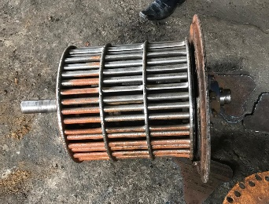
Figure 4. Rotor Bar
b. Stator Bars
The Stator Bar is a part of the ripple mill which is composed of 18 bars at the front and 18 bars at the back. The work of the stator bar is that the feed that enters the ripple mill will be rotated with the rotor bar and will hit the stator bar which is stationary, so that the nut will be ground and broken. The working hours on the stator bar are usually 3 times the life of the rotor bar, which is around 900 hours/unit. Welding was carried out on the stator bar using MG DUR 4 mm welding wire 3 times.
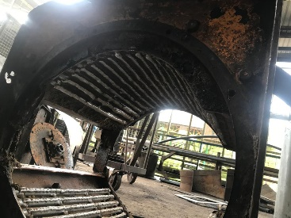
Figure 5. Stator Bar
c.V-Belt Pulley
A V-Belt is a belt or belt made of rubber and is used as a tool to transmit power from one axis to another by rotating a pulley at the same or different speeds.
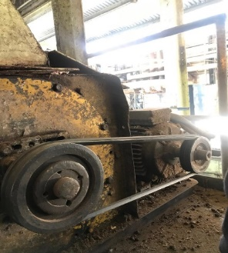
Figure 6. V-Belt Pulley
The V-Belt Pulley used at PT UWTL is the Bando Type B65 and B67 models. Where the use of the v-belt is in accordance with the position of the motorbike.
d.Flange Bearings
The bearing used at PMKS B is Flange Bearing 510. The purpose of the bearing here is as a place to mount the shaft before it is connected to the pulley, so that it remains in place and does not shift.

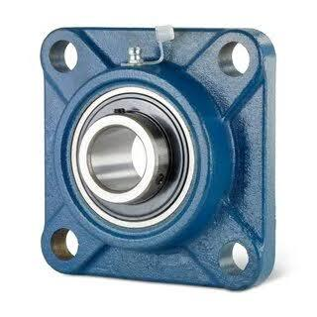
Source : https://www.kugellager-express.de/flange-housing-unit-ucf317-shaft-85-mm.com
Figure 7. Flange bearing

3.2 Ripple mill working principle
Ripple mill is a tool for breaking palm kernels, separating the shell from the kernel. In the ripple mill there is a moving part called the rotor bar, where this component is designed to consist of 40 hard bars (bars) and has a support called a dish, there are 4 dishes which are used to support the bar so that it does not shift and has a shaft to rotate the rotor. The rotor bar works at a fairly high rotation speed with the aim of producing an efficiency of 95% - 99%. The shaft on the rotor bar is supported by 2 bearings which can be adjusted and lubricated. The silent part of the ripple mill is the stator bar. The palm kernel (nut) will be fed from the nut hopper into the ripple mill and there will be a process of impacting and pressing repeatedly between the stator bar and the rotor bar. The rotor accelerates the movement of the palm kernel during the impact process, forcing the shell of the palm kernel to break and separate from the kernel.
To obtain optimal solving efficiency, things must be considered:
a. the size of the palm kernels fed, the size of the palm kernels is heterogeneous
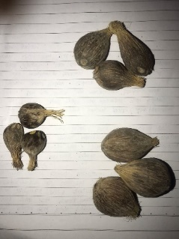
Figure 8. Actual size of palm kernels
b.getting the space between the rotor and the stator, if the distance is too tight it will cause a high percentage of broken palm kernels and if the distance is too loose then the palm kernel splitting will not be perfect, therefore the gap must be adjusted according to the provisions, namely 1/3 inch.
c. If the feed inserted is excessive it will cause blockages and will slow down the rotation of the rotor so that many nuts do not break.
Table 2. Raw Material Feed to Ripple Mill
Trial | Result (kg/menit)
1 | 96,6
2 | 93
3 | 94,2
4 | 93,6
5 | 93
Amount | 470,4
Average | 94,08

From the table above, the average incoming feed per minute is 93.48 Kg / Minute. If converted to per hour it becomes 5608 Kg / Hour or the same as 5.6 Tons / Hour. The Ripple mill at PT UWTL has an installed capacity of 6 tons / hour. So the incoming feed does not exceed the installed capacity.
d.The cleanliness of the fiber that is still included in the nut will directly affect the level of efficiency.
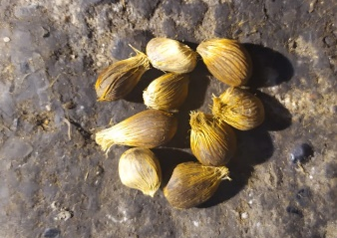
Figure 9. fiber included in the nut
  - Preventive Maintenance
This maintenance activity is to prevent unexpected damage from occurring and which can hamper the production process resulting in losses. Preventive maintenance needs to be carried out to maintain work efficiency at the ripple mill. The schedule for preventive maintenance is as follows:

Table 3. Schedule Preventive Maintenance Ripple Mill
Spare part | Activity | Weeks Condition |  |  |  |  |  | Add Information
Spare part | Activity | 1 | 2 | 3 | 4 | 5 | 6 | Add Information
Belt | Belting Tighness | V | V | V | V | V | V | Setting in 2th weeks
Bearing | Bearing Condition | V | V | V | V | V | V | Repalcement in 6th weeks
Rotor Bar | Rotor Bar Condition | V | X | V | V | V | X
note : V = Good , X = not Good
Preventive maintenance activities on ripple mill machines contained in PT UWTL can be described as follows:
- Prepare all the tools that will be used in the maintenance process
- Turn off the MCB of the ripple mill machine so that it does not turn on during maintenance.
- Clean all components from adhering dirt.
- Checking belting tightness.
- Check the condition of the bearings.
- Check the condition of wear on the rotor bar and stator bar.
- After completing maintenance, clean up all the tools used in the maintenance process.
- Restart the MCB on the ripple mill machine.
- Test the machine by running the ripple mill machine.
3.4 Maintenance Repair
In this maintenance, repairs or replacement of components are carried out that are damaged due to the age of the machine or 13other factors that can hinder the processing process. Maintenance repairs carried out at PT Unggul Widya Teknologi Lestari on the ripple mill machine were carried out based on the results of the decreasing ripple mill efficiency. In maintenance repair, there are 2 repairs carried out, namely replacing the rotor bar and adjusting the distance between the rotor and stator
3.5 Ripple mill efficiency data 4
At the PT UWTL palm oil mill, an analysis was carried out on the efficiency of the ripple mill. The following is efficiency data on ripple mill machine number 4 from 02 July 2021 to 05 August 2021.

Table 4. Effesiency Ripple Mill No 4
Data | Effesiency (%) | Target (%)
02-Jul-21 | 98,74 | 95-99
05-Jul-21 | 97,64 | 95-99
06-Jul-21 | 95,42 | 95-99
07-Jul-21 | 99,02 | 95-99
08-Jul-21 | 90,55 | 95-99
09-Jul-21 | 98,47 | 95-99
10-Jul-21 | 98,9 | 95-99
12-Jul-21 | 99,19 | 95-99
13-Jul-21 | 99,42 | 95-99
14-Jul-21 | 99,1 | 95-99
15-Jul-21 | 99,49 | 95-99
16-Jul-21 | 99,31 | 95-99
17-Jul-21 | 98,95 | 95-99
19-Jul-21 | 98,38 | 95-99
21-Jul-21 | 98,91 | 95-99
22-Jul-21 | 98,4 | 95-99
23-Jul-21 | 99,12 | 95-99
24-Jul-21 | 99,85 | 95-99
26-Jul-21 | 97,85 | 95-99
27-Jul-21 | 99,12 | 95-99
28-Jul-21 | 98,45 | 95-99
31-Jul-21 | 96,86 | 95-99
03-Agu-21 | 91,3 | 95-99
04-Agu-21 | 95,53 | 95-99
05-Agu-21 | 93,32 | 95-99

It can be seen in the table above that the efficiency of the ripple mill decreases only at the beginning and at the end. The ripple mill machine worked well in the middle, namely from July 9 2021 to July 31 2021, where the efficiency at that time was around 95% - 99%. The decrease or increase in ripple mill efficiency depends on the intact nuts and broken nuts contained in the cracked mixture.
The working hours requirement for the ripple mill machine is 300 hours / unit. For approximately 1 month, Ripple Mill No. 4 was used in the processing process and it was discovered that the working hours were around 320 hours/unit. Working hours for approximately 1 month can be seen from the log sheet at the nut & kernel station or in the process journal book. It is known that the working hours have exceeded the specified limits, but we can see from the table above that no problems will occur if the working hours of Ripple Nill No. 4 exceed the predetermined limits and the resulting efficiency is still around 95% - 99 %. From the ripple mill efficiency data above, it is known how many times adjustments and replacements were made on ripple mill machine number 4. The following is data on adjustments and changes on ripple mill machine number 4.

Table 5. Data Before & After Setting Ripple Mill
Date | Before | After | Target
06-Jul-21 | 95,42% | 99,02% | 95-99%
08-Jul-21 | 90,55% | 98,90% | 95-99%
03-Agu-21 | 91,30% | 95,53% | 95-99%

In the data table before and after adjustments, it can be concluded that 3 adjustments were made to the ripple mill machine for approximately 1 month, this was due to the analysis of the ripple mill efficiency decreasing and the rotor bar not yet experiencing wear. In Setup I the comparison of efficiency before and after setup was 95.42%: 99.02%. In setup II the ratio is 90.55%: 98.90%. In setting III 91.30%: 95, 53%. From this data it can be concluded that after adjustments I, II and III the efficiency of the ripple mill has reached the predetermined standard, namely 95% - 99%.
The steps for adjusting the distance between the rotor and the stator are as follows:
- Prepare all the tools that will be used in the process of adjusting the distance between the rotor and the stator.
- Make sure that the ripple mill is stopped.
- Remove the v-belt that is on the motor and ripple mill pulley
- Remove the bolts and nuts on the four sides of the bearing.
- Loosen the retaining bolt on the bearing housing, 1 full rotation of the retaining bolt will increase the distance between the rotor and the stator by 1.5 millimeters.
- Then use the pressure bolt to push the rotor towards the stator simultaneously. The distance between the rotor and stator is around 8.5 millimeters (1/3 inch).
- If the desired distance between the rotor and stator has been achieved, then tighten the retaining bolts until they touch the bearing housing.
- Then tighten all the bolts on the bearing.
- Rotate the rotor by hand to check that the distance between the rotor and the stator is correct.
- Reinstall the v-belt and the ripple mill is ready to be used again.
After making adjustments 3 times, there was a decrease in efficiency again on August 5, 2021. At that time the efficiency of the ripple mill decreased to 93.32%. This is caused by wear on the rotor bars. So a maintenance repair was carried out, namely replacing the rotor bar of ripple mill number 4. The replacement took 2 days, so that on August 7, 2021 the efficiency of the ripple mill could be checked.
The steps for replacing the rotor during maintenance repair are as follows:
- Make sure that the ripple mill is stopped.
- Unscrew the top bolt connected to the feed channel and the bottom bolt connected to the outlet.
- Remove the v-belt that is on the motor and ripple mill pulley.
- Lift the ripple mill body using the pulley to move the ripple mill to the workshop.
- Open the pulley on the ripple mill.
- Loosen the nuts and bolts on the bearing and side plate on the moving pulley.
- Remove the nuts and bolts on the studs on which the moving pulley is installed.
- After the bolts on the side plate and bearing have been opened, remove the side plate complete with the bearing housing.
- Pull/pull the rotor out on the opposite side of the side of the moving pulley.
- Then replace the rotor bar.

After replacing the rotor bar ripple mill number 4, an efficiency analysis of the ripple mill was carried out to determine whether the maintenance carried out was successful or not. The ripple mill efficiency analysis was carried out on August 7 2021 at the PT Unggul Widya Teknologi Lestari laboratory.

ripple mill efficiency analysis calculations on August 7, 2021.
Is known:
Sample = 1000.29 grams
Round nut = 6.78 grams
Broken nut = 7.37 grams
Round kernels = 267.10 grams
Broken kernels = 86.58 grams

Calculation :
% Round Nut = (6,78 gr/1000,29 gr) x 100% = 0,68%
% Broken Nut = (7,37 gr/1000,29 gr) x 100% = 0,74%
% Round Kernel = (267,10 gr/1000,29 gr) x 100% = 26,70%
% Broken Nut = (86,58 gr/1000,29 gr) x 100% = 8,65%
Effesience = 100 - %Nut Whole - %Nut Broken
Effesience = 100% - 0,68% - 0,74% = 98,58%

The results of the ripple mill efficiency analysis on August 7 2021 were 98.58%. The efficiency results obtained are in accordance with the established standards, namely 95% - 99%. This indicates that the maintenance repair, namely the replacement of the rotor, has been carried out well and the results of breaking down the ripple mill are in accordance with standards.
The steps in analyzing ripple mill efficiency are as follows:
- Prepare a sample container and tools for taking samples
- Take a sample of the cracked mixture at the output of the cracked mixture conveyor then weigh 1000 gr to the nearest gram (W1)
- Separate the cracked mixture based on categories, namely round nuts, broken nuts, whole kernels and broken kernels
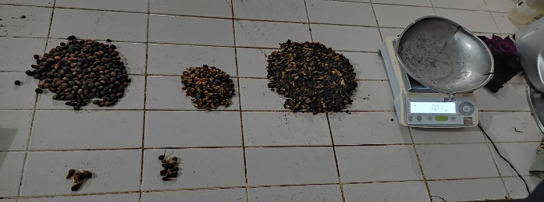
Figure 10. Round nuts , round kernels , broken kernels , and broken nuts
- Each category is weighed to the nearest gram respectively as W2 W3 W4 and W5
- Calculate the efficiency of the ripple mill
The following is data on the results of adjustments and replacements on the ripple mill machine.

Table 6. Result Setting & Replacment Ripple Mill
Action | Date | Before (%) | After (%) | Target (%)
Setting | 06-Jul-21 | 95,42 | 99,02 | 95-99
Setting | 08-Jul-21 | 90,55 | 98,9 | 95-100
Setting | 03-Agu-21 | 91,3 | 95,53 | 95-101
Replacement | 05-Agu-21 | 93,32 | 98,58 | 95-102

In the table above it can be concluded that after carrying out maintenance repairs , namely adjusting the distance between the rotor and the stator and replacing the rotor , the efficiency results obtained are in accordance with the predetermined standards, namely 95% - 99%. From the efficiency results obtained, it can be concluded that the maintenance repair carried out was successful and provided results in accordance with standards.

Conclusions

Conclusion of this research that is : based on the results of observations, things that influence optimal cracking efficiency are the heterogeneous size of palm kernels. The distance between the rotor and stator is around 8.5 millimeters or the same as 1/3 inch. Ripple mill performance can run well if the amount of incoming feed is not excessive. The amount of incoming feed is 5.6 tonnes/hour, not exceeding the capacity of the installed ripple mill, which is 6 tonnes/hour. Based on the data processing above, it can be concluded that maintenance activities in the industry need to be carried out so that the performance of the machines in the processing process, especially the ripple mill machines, can provide the best results. The efficiency of the ripple mill after maintenance shows results in accordance with predetermined standards, namely 95% - 99%. This concludes that the resulting efficiency is greatly influenced by the maintenance carried out. The relationship between efficiency and maintenance is directly proportional. If the maintenance carried out is correct, the efficiency results that will be obtained will also be good.

References

- Gee, P. T. (2007). Analytical characteristics of crude and refined palm oil and fractions. European journal of lipid science and technology, 109(4), 373-379.
- Rahardja, I. B., & Darmawan, A. (2020). The Effect of Oil Thickness in the Cylindrical Settling Tank on the Moisture and Impurities of Crude Palm Oil (CPO). Journal of Applied Sciences and Advanced Technology, 3(1), 21-28.
- Rahardja, I. B., Daraquthni, Z., & Ramadhan, A. I. (2019). Potential of palm oil solid waste as steam power fuel (case study at XYZ palm oil mill). Journal of Applied Sciences and Advanced Technology, 2(2), 33-38.
- Rahardja, I. B., Afifah, H., Dermawan, Y., Diniardi, E., Ramadhan, A. I., & Siregar, J. P. (2021). Mechanical Properties of Particle board from Empty Palm Fruit with Polyester Resin Adhesive. Journal of Applied Sciences and Advanced Technology, 4(1), 35-42.
- Obibuzor, J. U., Okogbenin, E. A., & Abigor, R. D. (2012). Oil recovery from palm fruits and palm kernel. In Palm Oil (pp. 299-328). AOCS Press.
- Poku, K. (2002). Small-scale palm oil processing in Africa (No. 148). Food & Agriculture Org..
- Harahap, M. A., Haeruman, A., & Mokheimer, E. (2023). Optimal Composition of Palm Oil Biomass to Minimize Biomass Power Plants’ Greenhouse Gases Emission. ASME Open Journal of Engineering, 2.
- Arysadiaga, Duhan. 2018. Analysis of Determining Machine Maintenance Time Using the RCM (Reability Centered Maintenance) Method at PT SANMAS DWIKA ABADI. University August 17th. Jakarta.
- John, Inyang, et al. "A model to manage crude palm oil production system." MATEC Web of Conferences. Vol. 255. EDP Sciences, 2019.
- Setyaningsih, D., Fahma, F., Wahyudi, A. T., & Mahendra, I. B. (2022, June). Technology innovation and business model of palm oil miniplant for food and energy. In IOP Conference Series: Earth and Environmental Science (Vol. 1034, No. 1, p. 012061). IOP Publishing.
- Hikmawan, O., Naufa, M., & Indriani, B. M. (2021). Pengaruh jarak rotor terhadap efisiensi pemecahan biji pada stasiun ripple mill di pabrik kelapa sawit. Jurnal Teknik Dan Teknologi, 16(31), 14-21.
- Hamdy, M. I., & Azizi, A. (2017). Analisis nilai Overall Equipment Effectiveness (OEE) pada mesin ripple mill. Jurnal Teknik Industri, 3(1).
- Perkebunan, S. T. I. P. A. (2015). Analisa Hasil Cracked Mixture Pada Alat Pemecah Biji (Ripple Mill) Kelapa Sawit Kapasitas 250 Kg/Jam. Jurnal Penelitian STIPAP, 6(1).
- Saraswati, A. (2012). Teknik Minimalisasi Kernel Losses di Claybath Pabrik Pengolahan Kelapa Sawit. JURNAL CITRA WIDYA EDUKASI, 4(1), 43-48.
- KUNCORO, G. M. S. (2013). PERENGKAHAN MINYAK KELAPA SAWIT MENGGUNAKAN VARIASI CAMPURAN KATALIS Ni/AlMCM-41, H-AlMCM-41 DAN BENTONIT; CRACKING OF PALM OIL USING VARIATION OF MIXTURE OF Ni/AlMCM-41, H-AlMCM-41 AND BENTONITE CATALYSTS (Doctoral dissertation, Universitas Gadjah Mada).
- Lesmana, A. (2021). Analisis Hasil Kinerja Mesin Ripple Mili di Stasiun Pengolahan Biji Pabrik Kelapa Sawit (Doctoral dissertation, Universitas Medan Area).
- Hikmawan, O., Naufa, M., & Indriani, B. M. (2021). Pengaruh jarak rotor terhadap efisiensi pemecahan biji pada stasiun ripple mill di pabrik kelapa sawit. Jurnal Teknik Dan Teknologi, 16(31), 14-21.
- Brown, N. P., Koretz, J. F., & Bron, A. J. (1999). The development and maintenance of emmetropia. Eye, 13(1), 83-92.
- Prajapati, A., Bechtel, J., & Ganesan, S. (2012). Condition based maintenance: a survey. Journal of Quality in Maintenance Engineering, 18(4), 384-400.
- Basri, E. I., Razak, I. H. A., Ab-Samat, H., & Kamaruddin, S. (2017). Preventive maintenance (PM) planning: a review. Journal of quality in maintenance engineering, 23(2), 114-143.
- Wang, Y., Deng, C., Wu, J., Wang, Y., & Xiong, Y. (2014). A corrective maintenance scheme for engineering equipment. Engineering Failure Analysis, 36, 269-283.

 Corresponding author. E-mail address: leksi@cwe.ac.id

