COVID 19 PANDEMIC: THE INSPIRATION TO START ONLINE BUSINESS
Zaitun¹, Faishal Juliyanto², Muhammad Sofian Hadi³
¹^{,2,3}English Study Program, Faculty of Education
Muhammadiyah University of Jakarta, Indonesia
Corresponding E-mail: faisaljuliyanto07@gmail.com
Mobile Phone / WhatsApp Number: 088290267066
Received: DD MM YYYY | Revised: DD MM YYYY | Approved: DD MM YYYY

Abstract

The pandemic of covid-19 which was announced as a disaster by President Joko Widodo on March 2, 2020 has been shaking the economic scope of Indonesia. More department stores and even big shopping centers forcibly closed due to the policy of social distancing and local lockdown. As the consequence, more people lost their jobs which worsening the economic sector. Besides this sadly fact, more people started to utilize social media to promote products. The changing of people’s behaviors who previously used to shop offline to online sites became the main reason for businesses owners to take this opportunity to keep their businesses survive. This new life style also inspired many people to start online trades to earn their livings. The objective of this descriptive paper was to present how one of English students of Faculty of Education, Muhammadiyah University of Jakarta, who joined entrepreneur class was being inspired by the situation of covid-19 to start online business. This study used both observation and unstructured interview as the tools in collecting the data. The results of the study presented three answers of the research questions, namely: first, the student was inspired by the rapid spreading of online business and most business owners who promoted various products online. Second, in the preparation, he determined a label as his virtual store name, designing logo, creating ‘thank you’ card and buying good quality materials with low prices for the packaging. Third, after the first three months becoming reseller of women’s stuffs such as body treatment, bags, shoes, cosmetics and various accessories, up to end of September, more than hundred goods had been sold and he could earn around one million of net-profit every month. Even more, currently, he has been saving money as the capital, stocking quite big number of stuffs and planning to have one physical store to run the business offline after the pandemic is over.
Keywords: economy in covid-19, online business, social media platforms
INTRODUCTION
Covid-19 has caused an economic shock, affecting the economy of individuals, households, micro, small, medium and large companies, even affecting the country's economy with local, national, and also global scope including Indonesia. This virus was firstly announced by President Joko Widodo on March 2, 2020 as a disaster. The National Disaster Management Agency (BNPB) specifically refers to Covid-19 as a non-natural disaster with a national scope. The corona outbreak has been attacking global economy in the short term. This scenario demonstrates the scale of costs that might be avoided by greater investment in all countries, particularly in the least developed and high-population ones.
The Covid-19 deadly virus has caused the economy of the entire country to become unstable. According to CNBC Indonesia (April 25, 2020), Covid-19 has devastated the world economy. Since emerging in the Chinese city of Wuhan late last year, the coronavirus disease has spread to 185 countries and territories - has infected more than 2.7 million people and killed more than 190,000 globally, according to data compiled by Johns Hopkins University. IMF chief economist Gita Gopinath said the restrictions, which the International Monetary Fund has dubbed the "Great Lockdown," brought much global economic activity to a halt, hurt businesses, and caused people to lose their jobs; huge unemployed everywhere. The World Trade Organization (WTO), in its latest forecast said that global trade volumes could fall by 12.9% or 31.9% this year - depending on the trajectory of the global economy. "Under both scenarios, all regions will experience double-digit declines in exports and imports in 2020," the WTO said. As the following graph 1 presented the expected decline in global merchandize trade:

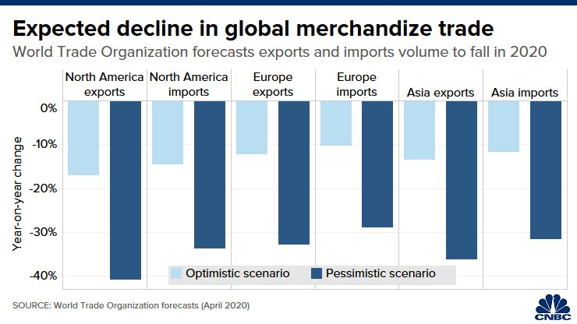
Graph 1: Global merchandize trade decline expectation
Source: https://www.cnbcindonesia.com/news/

However, there will always be blessings in every tragedy as well as in the impacts of pandemic in which some people can be inspired to start doing micro business in order to support their livings. Larasati, Bustaman and Pramana (2021) proved in their research that in Indonesia, micro retailers (based on number of products sold) dominated the online marketplace. Their argument was supported by Setiyawan and Prakasa (2021:30) who confirmed that “The emergence of various online shopping sites is part of life’s progress”
There was a plethora of research studies regarding the impacts of covid-19 on the business conducted by the scholars with various objectives. Putri (2021) was trying to find out the influence of the covid-19 pandemic on young online business. By applying mixed-method, she involved 20 respondents aged between 15 to 25 who were running online businesses in pandemic. The findings of her research highlighted 3 aspects. The first revealed that 37% of the respondents admitted that the most driving factor caused them doing online business was the current trends. The second finding explained that 37% of those participants found that in running online businesses they had to counter big number of competitors. The last point she found from the research was that by running online business, most of these young people got positive energy and this activity could be done without having to bother their academic activities.
Another study was carried out by Dianda and Pandin (2021), who qualitatively investigated how e-commerce has been strengthening the economy during the covid-19 pandemic. The results of their study showed that e-commerce increases in numbers during the pandemic. Further they explained that some companies that forcibly lay off due to decreasing in their revenue birthed e-commerce as the market to place the products to be sold. These big numbers of e-commerce businesses gave positive impact to the economy of Indonesia in which consumers started to visit e-commerce sites or applications more for shopping.
Among of the previous studies, including those two above, did not discuss how pandemic of covid-19 inspired people to start micro-online business. Therefore, in this study case paper, the writers explore the impact of Covid-19 on the small business landscape, particularly online business, focusing on three questions. First, how did Covid-19 inspire the subject of this research to start his online business? Second, to what extent did this subject research prepare the business? Third, how does the development of that business?
To explore, the writers surveyed one of small businesses owned by one of the students who joined entrepreneurship class in the study program of the faculty. The research was conducted between July 2021 to September 2021. The timing of this period allowed to understand the inspiration of that online business owner at a critical juncture during the development of COVID-19. The pandemic caused a lot of losses and lack of income. When the pandemic was going on very bad, this student could prove that he has been able to earn his living through the business.

Online business innovation
As one of the results of COVID-19 pandemic, the decline in the economic system experienced by various countries including Indonesia. It is undeniable that many business actors have begun to innovate for the development of their business. One of them is the development of online business which has begun to be seen by business people in Indonesia. Even now not only beginners in business are pursuing online business, but there are also many entrepreneurs whose businesses have been successful offline and now they have looked at online marketing to spread their wings of success. The increasing interest of the public and the magnitude of market opportunities are one of the reasons for business people to switch businesses to online platforms. This will not only certainly have a positive impact on business development on the internet, but also trigger increasingly fierce market competition between this business and other businesses.
Social Media Platform as a place to do business
In the current era of technology, many people are already using social media. Many people think of social media platforms like Twitter, Facebook, and Instagram as just a channel to communicate with friends and family. But in fact, the function of social media has become increasingly widespread for all types of businesses. Social media generates a large amount of data about customers. Every day there are more than 500 million Tweets, 4.5 billion likes on Facebook, and 95 million photos and videos uploaded on Instagram. Behind this huge number is a wealth of information about the customers; who they are, what they like, and what they think of a brand. There are a number of online platforms, specifically social media platforms, that can assist entrepreneurs in scaling and growing, and therefore, succeeding, but how they are used is important.
The following graphs 2 presented the data in which the most social media platform used by the world on social media platforms:

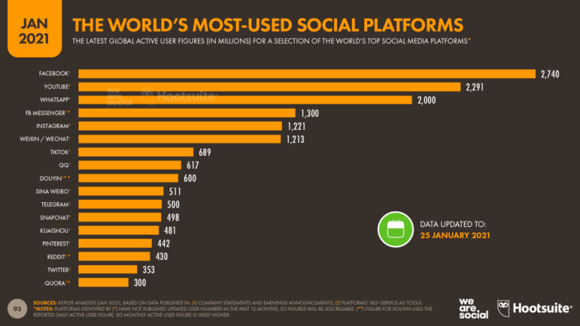
Graphic 2: Total Number of the World’s Most Used Social Platforms
Source: https://datareportal.com/reports/digital-2021-global-overview-report

While in the smaller context, namely to Indonesians, the following graph 3 reported the amount of time the people spent daily on their preferred media:
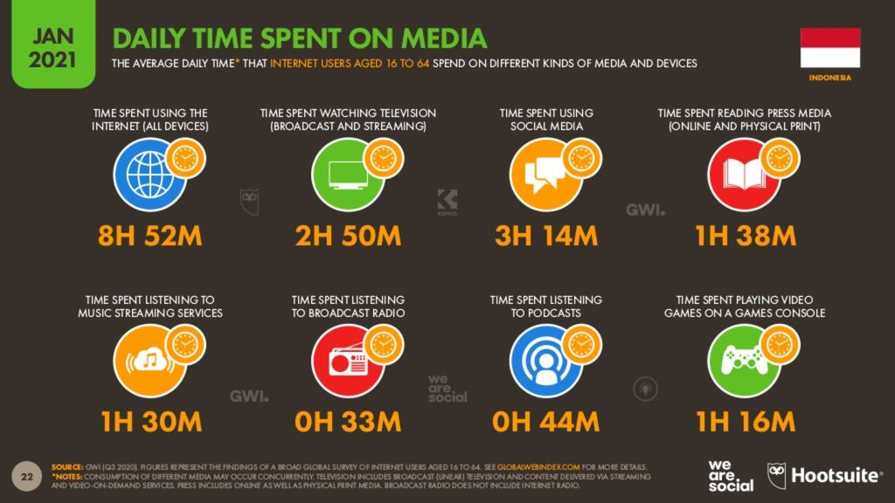
Graphic 2: The Amount of Time Spent by Indonesian People on Media
Source: https://tekno.kompas.com

As in the data above, based on people’s preferences, it can be seen that there are very huge number of active users of social media around the world, ranging from Facebook to Twitter, interestingly, the amount of time Indonesian people spent on social media with various age groups and numerous purposes is also in fantastic scale.

RESEARCH METHODS
This research applies qualitative method with study case design. One student who joined entrepreneurship program as one of the subjects proposed by English study program in the grant of Centre of Excellence from Ministry of Research and Technology of the Republic of Indonesia (Kemenristek RI) was selected to be observed and interviewed further related to his online business. Therefore, the data presented as the discussion in this study were gathered from what the researchers observed on the business supported by the results from the unstructured interview.
It was a short period of study which spent about 3 months. The main reason for selecting this student out of the other 9 who were also participated in this entrepreneurship program because this student just started his business in the mid-time of Covid-19, on August last 2020. And based on the initial interview, he said that he was inspired by the pandemic in which most people switched to and began their business online.

RESULTS AND DISCUSSION
The findings of this study highlighted three major results as the answers of the research questions which were comprehensively got from both observation and unstructured interview.

How COVID-19 inspired to start online business
COVID-19 pandemic has had a major impact on businesses, especially those who have offline ones, therefore many of them are spreading their wings to keep up with current business developments, namely online trades. Technology, in this case social media plays an important role for these business owners in promoting the products to be offered to buyers. The pandemic gave this student much vacant time since the regular classes are also conducted virtually. He found many of his close friends, relatives and also neighbors have been suffering losing jobs and bankrupts. Economic sector has been becoming the worst field affected by the pandemic. Along with this sadly fact, people started changing not only their behaviors in buying things but also in selling goods. It took this student about 6 months to observe and learn how the business online was carried out and managed in this pandemic time.
From what he learned, he understood that the products offered virtually were sold more than the conventional one (through offline trade such as physical shop places). Most of department stores even the big malls closed or even worse, in which some of them were getting bankrupts due to lockdown announced by the government. People did everything from home as well as buying things. Therefore, many online businesses started to grow up rapidly. The business doers competed to utilize the social media to display, offer and sell the goods they were selling.
Based on his observation and learning aforementioned above, finally this student got the inspiration to start running his online business.

The extents in which this student prepared the business

One of his observations revealed that women’s stuffs were offered and sold more than other goods after food. This conclusion led him to the idea to start selling women’s stuffs through his social media, namely WhatsApp and Instagram. He understood that women shop a lot more than men. They have regular needs such as cosmetics and various kinds of body treatment; from top to toe. Besides, some girls like to collect bags, shoes and other accessories to support their appearance. Social distancing does limit the way women buyers in buying things but not their needs, especially those who do not have problem with their finance.

The first thing this student made was obviously the process of finding name for the store. This student described that he was confused at first to find one proper name. He thought of having a ‘label’ in which could make the buyers or people remembered his store as well as he himself as the owner of that shop. Coincidentally, one of his friends suggested him to use his own name followed by the word ‘stuff’.
By having the name as the label of this online store, what did next was creating a logo to be displayed on the shop’s start page of his social media. With the logo, everyone will know the character of the business or that his virtual store does sell quality goods. As Machado (2015) argued in order to reach positive affective response, managers should be guided in selecting or modifying logo designs.
He made his own logo with the help of his friend through an application on the Internet. In addition to the logo, he also said that the arrangement of photos or feeds on Instagram becomes another aspect that needs to be considered since people will see the page. If the initial page is good, the prospective buyers will believe the product is good, but on the other hand, if the start page is not good, the buyer will not be interested to stay on that page for long time.

After the components discussed above; shop label, logo creation and social media page, the next things that he prepared were thank you card and packaging. At this process, he surveyed, compared and then made several designs before deciding to choose one. The design created to represent the characteristics of the business. Especially for the packaging, he chose good quality of boxes but in a low price. He made sure that strong materials of the box would be safe to be used to send the package to long distance cities. While for the prices itself, he also picked the lowest price so that the profit from each item sold could still cover the costs spent on one packaging.

The next thing after this stage of preparation was that he started hunting several online products’ distributors or goods manufacturers for women’s stuffs such as skin care products, bags, and accessories. Since in the initial business he did not have enough capital to stock these goods, then at the first three months, he just became reseller. This idea was great as Martinuzzi (2021) explained that financial burden for expenses and capital expenditures needed can be shared by having a business partner.

By becoming a reseller, this student just needed to repost the items that he would like to offer on his social media and then he opened purchase order (PO). Once there was a buyer ordered one of the items, he contacted the respective distributor to buy that item. In order to make sure that the quality of the purchased item was really good, he firstly asked the distributor to send the item to his place. Having got the purchase, then he re-wrapped the material before it was being sent to the buyer. By applying this way, the student said that it gave consequences both in positive and negative impacts.

The positive effect was that he could give guarantee to his buyers that the items they have ordered was really fulfilled their expectations since he has checked the condition of the items. He did not want to disappoint his customers if the items they ordered was different from what products’ distributors had offered. Meanwhile, the negative sides of this reselling process went to two facets; in terms of delivery costs and time. Most distributors apply selling strategy by determining minimum number of products’ order. Thus, when he only got one purchase order, delivery cost was paid by him which also meant doubled-up that delivery costs to be arrived at buyer’s hand. These two shipments process (from distributor to this student and then from this student’s shop to the buyers) spent longer time of goods’ delivery. It needed around 3-4 days (some even more) for one purchase item to be received by the buyer depending on the shipment services.

The development of the business

After three months becoming the reseller, this student was able to collect the capital taken from the profit he got. At first, he spent around IDR 500.000,00 to be invested in buying the materials for the ‘thank you card’ and the packaging. Also, he kept some money for the pre-order and shipment costs. In those three months, he was able to sell at least two products in a week with the net profit between 35% to 50%. When he got enough capital, then he started to buy several stuffs in a bigger number and stocked those things.

By doing this way, the customers were treated better in terms of faster shipment. When one item was ordered, he did not need to wait the item arrived from the distributors. Besides, since he had several stocks of products, it made him more confident to offer those things to the buyer-candidates. Until the end of September 2021, more than hundreds of goods have been being sold with the average profit of one million in a month. Further, he has been saving bigger amount of capital and more various numbers of stocked stuffs. He has been planning to develop this online business by having one physical store in 2022. This planning arises as the preparation if all the livings get back to normal after the pandemic is over.

CONCLUSION
The COVID-19 pandemic has been shaking world’s economic sector to the very worse point including to Indonesia. This disaster has been changing people’s behaviors in buying things in which they have been favoring to shop online, hence online trades started to become booming in all social media. This phenomenon was supported by social distancing and or local lock-down where people were limited to do their activities outside home. The sadly fact of various shopping centers including popular and big malls had to close because there was no buyer allowed to go to public places, also created new way of selling which was switched from offline to online.
Having seen this new trend of business, one of the students, as the research subject in this study, was getting inspired to start online business on July 2020 which sells women’s stuffs such as bags, shoes, body-treatments, cosmetics and various accessories. He began the business by preparing the name of his virtual store together with the design of this store social media pages, making logo, creating ‘thank you’ card, and buying packaging stuff followed by searching products’ distributors which sell good quality of things with lower prices. Due to his limited capital, he became the reseller for the first three months.
By managing the business well through the selections of good quality of things to be offered and doing consistent promoting both in WhatsApp and Instagram, he was able to pump up the selling and able to save more capital taken from the profit he earned. Up to end of September 2021, more than hundred goods have been being sold and even more, he has been putting various numbers of goods to be stocked in order to respond to the customers’ orders faster.
To end, the findings of this research are in line with what Betterton (2021) claimed that “The current pandemic has opened up the door for new and expanded business opportunities as consumers adapt to post covid-19 life”.

REFERENCES
Betterton, K. (2021). 13 post-pandemic business you can start now. STARTUP, on: https://www.uschamber.com/co/start/startup/business-to-start-during-pandemic, accessed on: October 5, 2021.

Dianda, A & Pandin, MGR. (2021). E-commerce strengthening the economy during the covid-19pandemic: a historical review. Jurnal Ekonomi dan Bisnis Jagaditha, Vol. 8 (2), 179-186.

Kemp, Simon. (2021). Digital 2021: Global overview report. DATAREPORTAL, https://datereportal.com/reports, accessed on Oct 5, 2021.

Larasati, DN., Bustaman, U., Pramana, S. (2021). Online marketplace data to figure covid-19 impact on micro and small retailers in Indonesia. Indonesian Journal of Statistics and Its Applications, Vol. 5 (2), 333-342. https://doi.org/10.29244/ijsa.v5i2p333-342.

Machado, JC. (2015). Brand logo design: examining consumer response to naturalness. Journal of Product and Brand Management, Vol. 24 (1), 1-22. DOI:10.1108/JPBM-05-2014.0609.

Martinuzzi, B. (2021). The advantages and disadvantages of a partnership. Accessed from: https://www.americanexpress.com/, on: Oct 12, 2021.

Putri, NS. (2021). The influence of the covid-19 pandemic on young online businesses. Indonesian Journal of Social Sciences, Vol. 13 (1), 1-10.

Rina, Ratu. (2020). Ini 7 bukti covid-19 telah bikin ekonomi dunia hancur lebur. CNBC Indonesia, https://www.cnbcindonesia.com/news/, accessed on: Oct 4, 2021.

Setiyawan, S. & Prakasa, SUW. (2021). Indonesian online shopping practices in the covid-19 pandemic era: A study of culture and cyber security law. NOVELTY, Vol. 12 (1), 29-44.

Stephanie, Connie. (2021). Berapa lama orang Indonesia akses internet and medsos setiap hari? KOMPAS.Com, https://tekno.kompas.com, accessed on: Oct 2, 2021.

